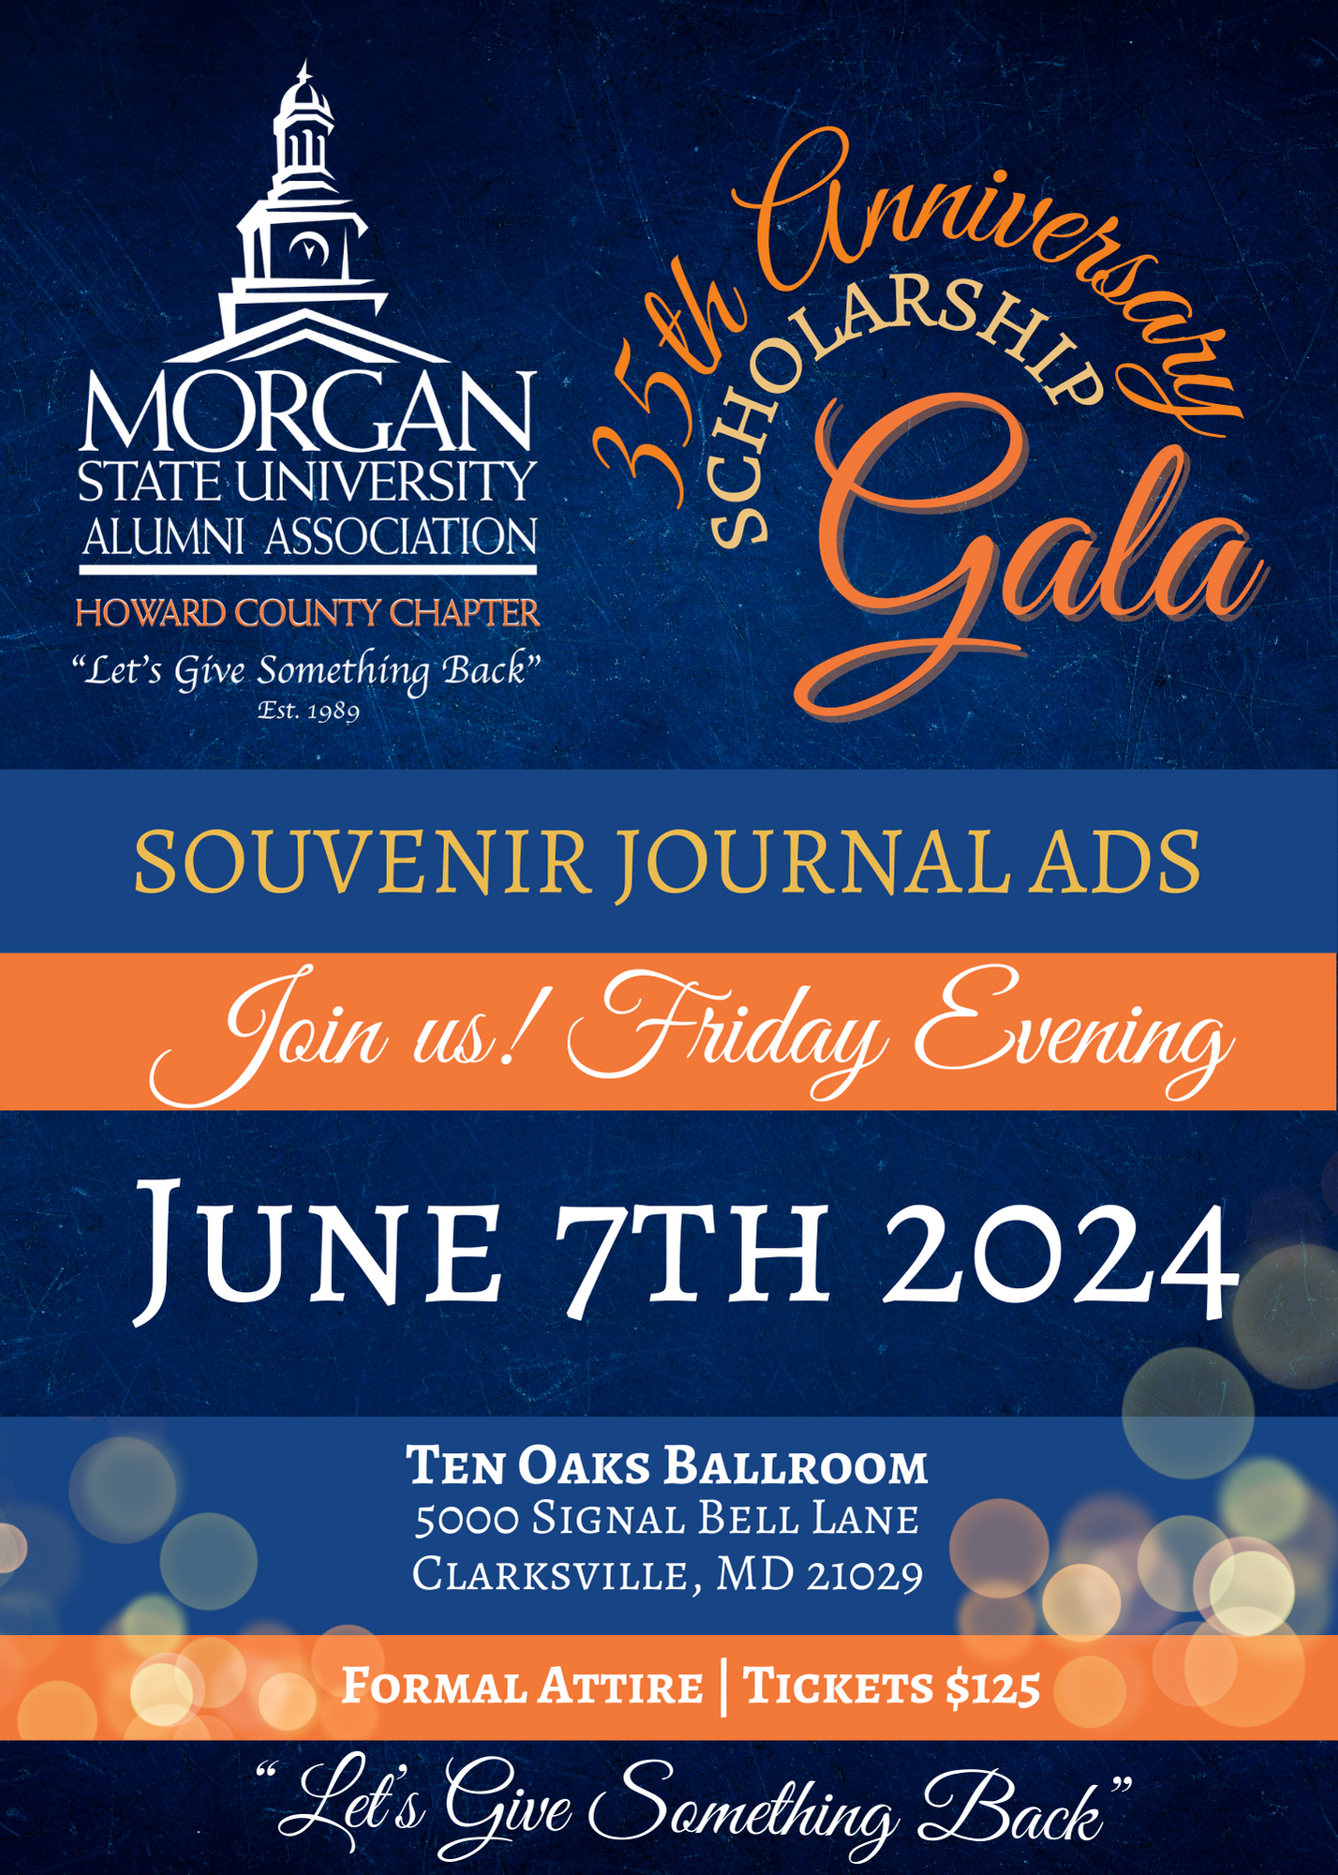

Greetings Morganites, Supporters and Friends:
The Morgan State University Alumni Association Howard County Chapter (MSUAA-HCC) is celebrating its 35th Anniversary on Friday, June 7, 2024 at the Ten Oaks Ballroom. This premiere event will provide an opportunity for us to acknowledge the Chapter’s Charter Members and to recognize our 2023-2024 Scholarship Recipients.
Chartered in 1989, The MSUAA-HCC is a non-profit organization. Our chapter motto “Let’s Give Something Back”, provides Howard County Alumni with the opportunity to support Alma Mater through our fund-raising events and other supportive activities. With the support of the community, friends and family, we have been able to raise thousands of dollars for scholarships for new and continuing students at Morgan State University.
We are once again asking for your support. This time we are asking you to purchase an advertisement in our 35th Anniversary Commemorative Journal. Your program ad will help us provide money for scholarships for students as well as exposure for your business. This professionally designed journal will provide further exposure to fellow Morgan Alumni as they browse the Journal at their leisure. In addition, your message will be distributed in an electronic version of the booklet to our wider area Morgan Alumni. Your exposure will be broadened, and your support will encourage more of our alumni to utilize your business as well.
Attached you will find an advertisement request form with all options available, including instructions for providing the art work and payment for your advertisement. If you need any assistance at all, please feel free to email us at howardcounty.chapter@alumni.morgan.edu. On behalf of the MSUAA-HCC and the past, present and future Morgan students, we want to thank you for your sponsorship through the purchase of a program ad and for making this the most successful Journal ever.
Sincerely,
Paul Haley, President
Morgan State University Alumni Association
Howard County Chapter

35th Anniversary Gala - Journal Advertisement Information

Event Date: June 7th, 2024
Ad deadline: May 5th, 2024

Ad Size/  Location | Price | File Size  (Width x Height)
Center Spread | $450 | 17” x 11”
Outside Back | $300 | 8.5 x 11
Inside Front | $300 | 8.5 x 11
Inside Back | $250 | 8.5 x 11
Full page | $200 | 8 x 10.5
Half Page | $125 | 8 x 5
Quarter Page | $70 | 4 x 5.25
1/8 Page | $40 | 4 x 2.5
Business Card | $40 | 4 x 2.5
Patron Page | $25 | Name Listed on Patron Page
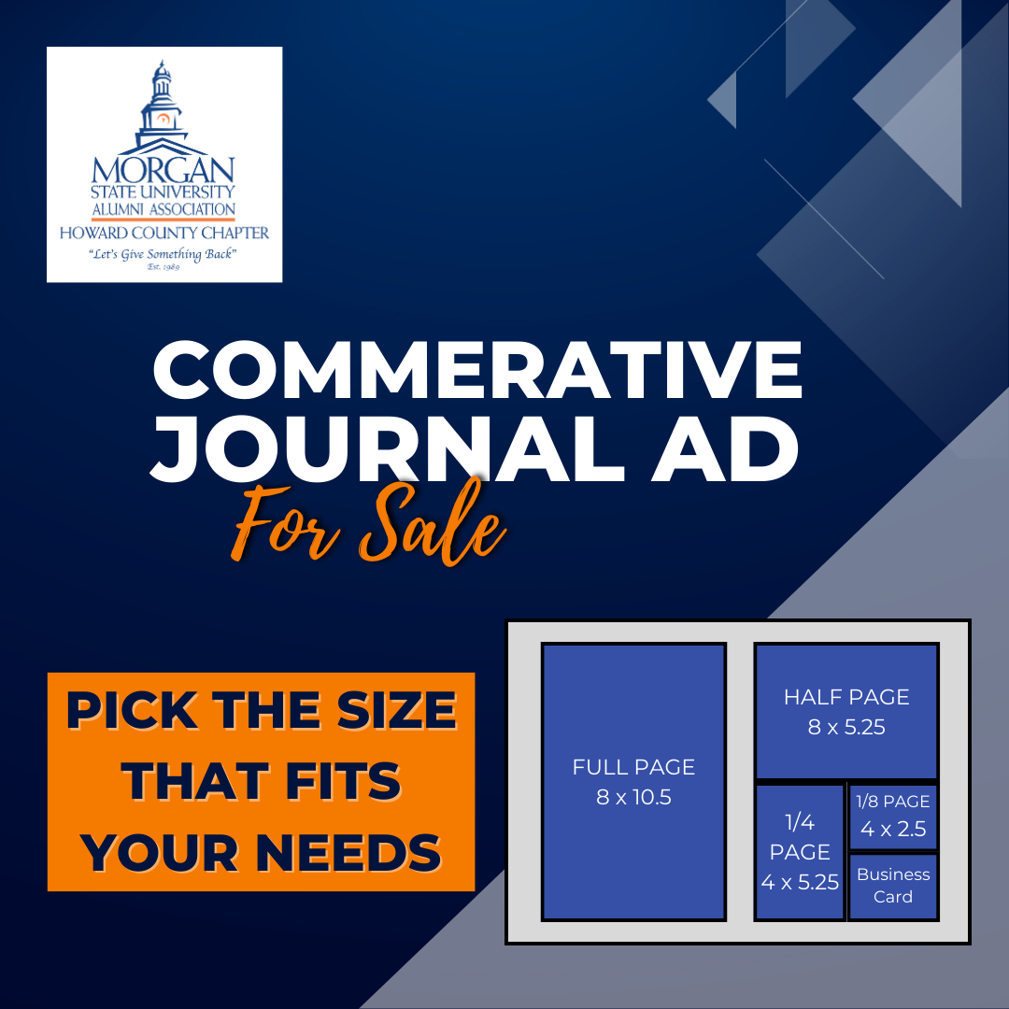

Options to Place an Order |  | Payment Information
Option 1:  - Submit the order form online at www.msuaa-hcc.org/gala-ad  Option 2:  - Fill out the order form below  - Mail your check and printed order form or Pay via PayPal  - Email your images and order form attached to howardcounty.chapter@alumni.morgan.edu  Option 3:  - Fill out the order form below  - Mail your check, printed order form, and pictures/business card |  | PayPal Link:  - https://bit.ly/hccgala35  Check (Offline Payment):  - Payable to: MSUAA-HCC  - Memo: Gala Journal Ad  - Mail Checks to  MSUAA-HCC  P.O. Box 6847  Columbia, MD 21045  ***

*** If you need your ad professionally designed, email howardcounty.chapter@alumni.morgan.edu
(*priced individually)
- SUBJECT: AD FOR MSU GALA - YOUR NAME
- In the body of the e-mail please include your name, content (message you’d like within the ad) attach any pictures, logos, give an explanation of your idea, size, and payment confirmation
- Email or mail all Advertisements (in PDF or JPEG format), business cards, and non-artwork
- If you have any questions, please don’t hesitate to email: howardcounty.chapter@alumni.morgan.edu
MSUAA-HCC 35th Anniversary Gala Advertisement Order Form
Full Name:

Company/
Organization Name:
Email:

Phone:

Referring Chapter Member:
Signature:

(Sign electronically, by typing your name in the signature box, it is a legally binding document.)

Please check your __X__ ad size below:
AD SIZE/LOCATION | X | PRICE | FILE SIZE
Center Spread |  | $450 | 17 X 11
Outside Back |  | $300 | 8.5 x 11
Inside Front |  | $300 | 8.5 x 11
Inside Back |  | $250 | 8.5 x 11
Full page |  | $200 | 8 x 10.5
Half Page |  | $125 | 8 x 5
Quarter Page |  | $70 | 4 x 5.25
1/8 Page |  | $40 | 4 x 2.5
Business Card |  | $40 | 4 x 2.5
Patron Page |  | $25 | Name Listed on Patron Page
*All ads will be printed in color

Payment Information
PayPal Link: https://www.paypal.com/donate/?hosted_button_id=825CGCMC6DN82
Make Checks Payable to: MSUAA-HCC with Memo: Gala Journal Ad
Email, Order Form, Proof of Payment, and Images to: howardcounty.chapter@alumni.morgan.edu
Mail Order Form, Checks, and images to: MSUAA-HCC, P.O. Box 6847, Columbia, MD 21045

